Q . Create a table student (student_id,name) . now create a application which can have search,add,delete functionality in application.

Solution:

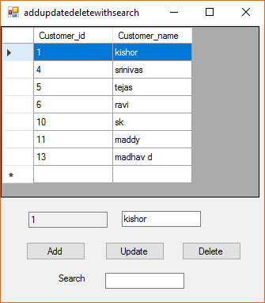

Imports System.Data.SqlClient

Imports System.Data

Imports System.Configuration

Public Class addupdatedeletewithsearch

Dim conString As String = "Data Source=.\SQLEXPRESS;AttachDbFilename=C:\Users\ktrim\Documents\customerdb.mdf;Integrated Security=True;Connect Timeout=30;User Instance=True"

Dim con As New SqlConnection

Dim cmd As New SqlCommand

Dim ds As New DataSet

Dim dt As New DataTable

Private Sub addupdatedeletewithsearch_Load(sender As System.Object, e As System.EventArgs) Handles MyBase.Load

datafill()

End Sub

Private Sub datafill()

con.ConnectionString = conString

cmd.Connection = con

con.Open()

cmd.CommandText = "select * from customer_table"

Dim da As New SqlDataAdapter(cmd)

da.Fill(ds)

da.Fill(dt)

DataGridView1.DataSource = ds.Tables(0)

con.Close()

End Sub

Private Sub btnadd_Click(sender As System.Object, e As System.EventArgs) Handles btnadd.Click

con.ConnectionString = conString

cmd.Connection = con

con.Open()

cmd.CommandText = "insert into customer_table values('" & txtcustomername.Text & "')"

cmd.ExecuteNonQuery()

MsgBox("data is inserted")

con.Close()

ds.Clear()

datafill()

End Sub

Private Sub btnupdate_Click(sender As System.Object, e As System.EventArgs) Handles btnupdate.Click

con.ConnectionString = conString

cmd.Connection = con

con.Open()

cmd.CommandText = "update customer_table set customer_name='" & txtcustomername.Text & "' where customer_id='" & txtcustomerid.Text & "'"

cmd.ExecuteNonQuery()

MsgBox("data is upadted")

con.Close()

ds.Clear()

datafill()

End Sub

Private Sub btndelete_Click(sender As System.Object, e As System.EventArgs) Handles btndelete.Click

con.ConnectionString = conString

cmd.Connection = con

con.Open()

cmd.CommandText = "delete from customer_table where customer_id='" & txtcustomerid.Text & "'"

cmd.ExecuteNonQuery()

MsgBox("data is deleted")

con.Close()

ds.Clear()

datafill()

End Sub

Private Sub DataGridView1_CellClick(sender As System.Object, e As System.Windows.Forms.DataGridViewCellEventArgs) Handles DataGridView1.CellClick

Dim id As Integer = DataGridView1.CurrentCell.RowIndex

txtcustomerid.Text = ds.Tables(0).Rows(id)("customer_id").ToString()

txtcustomername.Text = ds.Tables(0).Rows(id)("customer_name").ToString()

End Sub

Private Sub txtsearch_TextChanged(sender As System.Object, e As System.EventArgs) Handles txtsearch.TextChanged

Dim dv As New DataView(dt)

dv.RowFilter = String.Format("customer_name like '%{0}%'", txtsearch.Text)

DataGridView1.DataSource = dv

'dv.RowFilter = String.Format("Ename like '%{0}%'", txtsearch.Text)

'DataGridView1.DataSource = dv

End Sub

End Class

